**Lab 9:**

**Programming Fundamentals (CS-130-02) CS 130-02 FA 2022 Total=100**

Open Eclipse IDE and create a new class for each of the following questions: Choose class name that most appropriately defining the problem. Take a print screen of the code with console output.

Question 1.

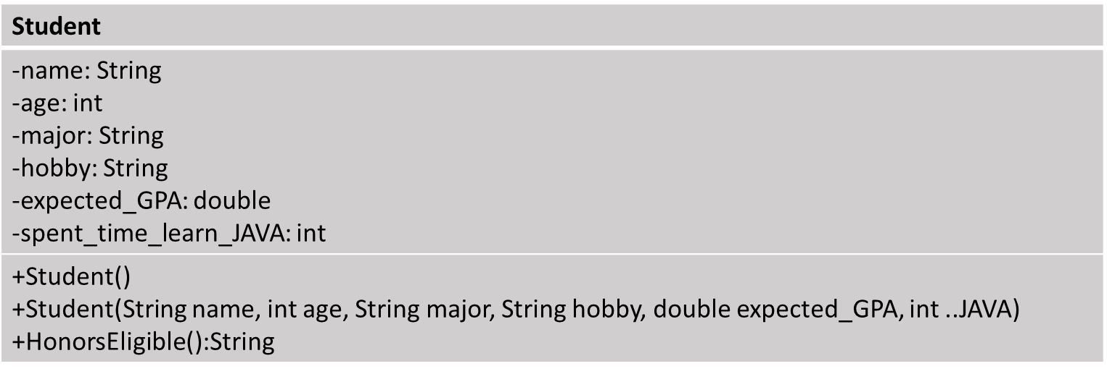

1. Implement the Student UML diagram with the above inputs
2. Create proper constructer and access all the private elements using getter and setter
3. Create a new method called HonorsEligible. If the student expected_GPA is more than 3.5, the student eligible for honors (True) else it will return False.

Question 2.

|  |  |  |
| --- | --- | --- |
| **Class** | **Attribute** | **Method** |
| Cylinder | -radius:double  - height:double | +AreaCylinder():double  +VolumeCylinder():double |

1. Create Cylinder constructor, calculate area and perimeter of the cylinder for radius 10, height 5

